**Spike:** Spike 13

**Title:** Composite Pattern

**Author:** Bernardo Fitzmaurice Acevedo 105297603

**Goals / deliverables:**

To expand the Zorkish activity of the previous spike, where game entities can be composed of other game entities and the game to support actions that modify the composition and location of game entities.

Besides this report, what else was created?

* Code called “Task_13” and is composed of multiple classes.
* Text file called “Adventure.txt” that holds all locations, entities and connections.

**Technologies, Tools, and Resources used:**

List of information needed by someone trying to reproduce this work

* Visual Studio 2022
* Microsoft Word
* Notepad

**Tasks undertaken:**

* Download and install VS community 2022.
* Copy, paste and open the code of the previous task.
* Modify the text file, adding new “sub”-entities, with their respective descriptions and locations inside other entities.
* Modify the “Entity” class to allow “nested entities” (entities inside another entity)
* Create the “LookInCommand” class, that allows users to look inside entities that can hold other entities.  
  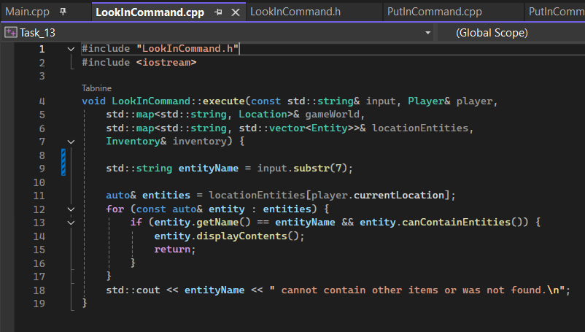
* Create the “TakeCommand” class that allows users to take an entity from another that is a container.  
  A screen shot of a computer program

  Description automatically generated(there’s more)
* Create the “PutInCommand” class that allows users to put certain entities inside the entities that are also “Containers”.  
  A computer screen shot of a program code

  Description automatically generated(There’s more)
* Modify the “HelpCommand” class to show the commands of the new classes.  
  A screenshot of a computer program

  Description automatically generated
* Modify the main loop to run and loop the new commands.
* Compile the code. (Picture of the compiled code on the next point)

**What we found out:**

This spike allowed me to learn how to modify pre-existing classes and to create new ones that interact with other classes that existed before. It also allowed me to learn how to modify and improve a text file, adding all the information needed for the update on the program.

All this can relate to the topic, since it allowed me to grab and move entities, therefore, modifying them.

**Open issues/risks:**

This is a risk, but an error. I can move “nested entities” from one container entity to another, but only if they are in the same location. Otherwise, it acts like I’m trying to put an outside item to the container. And while trying to fix it I jammed my code more than one and had to go back to previous backups that I had, and then try to restore any advancement that I lost.

**Recommendations:**

Trying to add “nested entities” to another location’s containers does not break the game. But when I tried to modify the code, it broke several times. But I know that the way to do it is with a “global map” that stores all “nested entities”.